Session plan: Turning ideas into a project (Share/Conserve Stage)

Session aim: To support young people to turn understand the issues and develop an idea to have a positive impact on community and link to conservation

Activity | Delivery suggestions | Aim | Resources
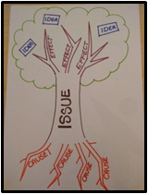Solutions Tree | - Draw out a Solution Tree, or ask the group to (see template)  - First, support the group to decide on the issue they will explore writing this in the trunk of the tree, encouraging them to be as specific as possible (e.g. lack of green spaces locally, young people not using these green spaces)  - Then go to the ‘roots’ and ask the young people add things that cause the issue here  - Then move onto the ‘branches’, asking young people to write down effects of this issue  - Finally, ask the group to discuss and share different ways they could tackle or make a positive contribution in this area – write each idea on a post-it and these become the ‘fruit’ of the tree | To be specific about the issue, understanding the causes and effects, leading to ideas of what the group could do | Flip chart  Pens  Post its  Issue Tree model
Doable v effective | - Following the Issues Tree activity, use the post-it’s containing different ideas or solutions of what could be done by the group to tackle or improve the issue  - Use the diagram opposite to have the group rate and put their ideas on post its onto the diagram of the impact vs how doable it is in order to decide what is realistic or what will be done first – how much of a challenge do they want? What is the perfect balance of the two?  - Encourage the group to move away from any  idea that is going to be hard to do and not very  effective | To help make a decision about which project idea to take forward and as learn more about the concept of impact vs. how doable | Flip chart  Pens  Post-its
Balloon activity | 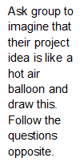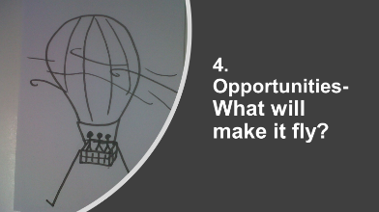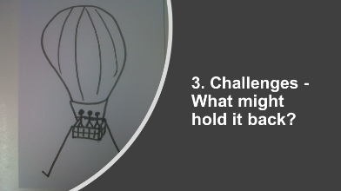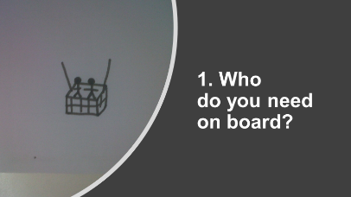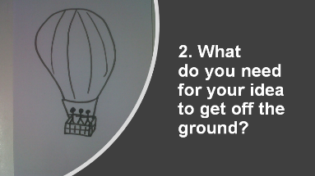 | To explore which people are needed, what resources they’d need, the challenges and the opportunities for their campaign or project idea. | Flipchart  Pens  Balloon activity
Partnership working | - As a part of Keeping it Wild we ask all groups to work in partnership – this can be an organisation that’s not a youth club/organisation and is relevant for the project/campaign  - We’d encourage the young people to take the lead as much as possible with this partnership, which could include the young people:  - Identifying appropriate partners  - Finding relevant contact details and deciding the best way to get in touch (email, phone, face to face)  - Agreeing on what the ask is of the partner including the benefits for them and clearly communicating the project idea  - Deciding who will contact the partner  - Planning next steps after initial contact and how the group will communicate well with the partner | To identify community partners the group can work with as part of their community stage campaign or project.
Campaign vs Project | - This is a tool that can be used to build a campaign element to the activities young people run. Running through this activity will help teams explore what makes something a campaign.  - Ask the group to share what they think makes a campaign a campaign. You could follow up with asking “how is this different to a project?”, note down answers  - Briefly introduce the team to the ‘Campaign v Project’ model, explaining that the ‘Why’ is the same but the ‘How’ differs depending whether you run a campaign or a project.  - Ask the team to split into two smaller groups and get one to look at ‘Project’ and the other to look at Campaign’, sharing what they think of the differences and similarities and what they like about each. | To explore the key components of a campaign and how this is unique and different to a project | Campaign vs Project model (see ‘Tools’ section of this Handbook)
Making it a campaign | - To help teams ensure develop their ideas so that they have a campaign element they can make sure it will:  - Make a positive change – What difference do you want to make? (e.g. challenge negative perceptions of young Muslim women)  - Have an ask or ‘call to action/raising awareness; – What do you want people to do or know about? (e.g. share video online, sign petition, join one of their events)  - Be visible, with clear audience and reach – How will other people know what you are doing? Who are you targeting? Why?  (e.g. a physical workshop, online videos, social media posts)  - Work with the group to explore these areas ensure these elements are covered in the activity they want to do. | To introduce a framework that will support the planning of team’s campaign
Planning and evaluating a ‘call to action’ | - We suggest that when planning how they will evaluate their project or campaign young people should consider:  - How will know you’ve had an impact? (e.g. number of positive comments about the campaign, tracking how people’s views have changed)  - When will things (milestones) need to be achieved by?  - What will success look like? (i.e. number of people attending events, numbers of signatures, completing certain milestones)  - You can also ask the team to take turns to sit on a panel and get other young people or staff to ask them questions like the above

Session plan: Presentation Skills (Share/Conserve stage)
Session aim: To develop young people’s presentation skills including increasing confidence around presentations

Activity | Delivery suggestions | Aim | Resources
Introducing presenting | - Ask young people what is important in presentations – listen to what they say and write it up  - Introduce the Speakers Trust resource of a triangle around public speaking – delivery, content, structure and fit all the things that they said were important to match up with the triangle | To introduce the basic core elements of presentation give and what is important to cover | 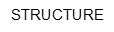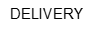
Building confidence and skill | - Ask each young person to stand up say ‘hi, I’m X’ in a confidence clear way to the rest of the group – encourage them that they have just taken the first step in presenting  - Ask each young person to think about a topic (or select a topic/ask something in the group to pick a topic) for them that they will speak on for 30 seconds or 1 minute – encourage everyone in the group to have a go and give feedback based on the triangle – ask them to try again  - Encourage each young person to be filmed while presenting and then watch it back (individually, in pairs or as a group) to spot what works well and what could be improved | To start to get all young people comfortable with presenting but having a go and start to work on giving feedback to each to improve their skills

Session plan: Reflection (Share/Conserve Stage)
Session aim: To develop young people’s understanding of what reflection is and give an opportunity to use this through Keeping it Wild

Activity | Delivery suggestions | Aim | Resources
What is reflection? | - Ask the young people to talk in pairs about what they think of when they hear the word ‘reflection’  - Feedback as a group and from what the young people say and pull out key words / concepts  - Ask the young people why they think reflection is (or isn’t!) important – either as a pairs/group discussion or as a debate with one group taking on each position (reflection is / isn’t important) and then feedback as a group  - Share the quotes (or any others) as to why it’s considered so vital and what benefits could be – it’s a great way to get positives from negative situations and to take the most from anything learnt | 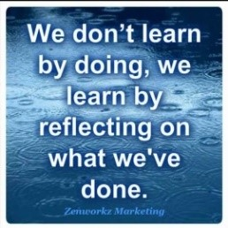To understand what the young people already know about reflection and explore why it’s important | 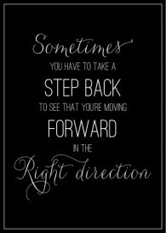Quotes
Different reflective cycles | - 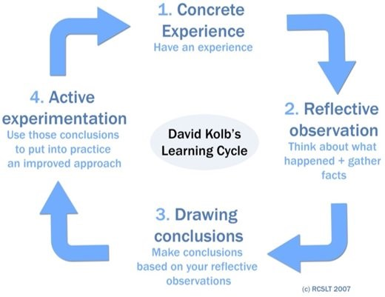Outline the stages in reflective tool here  (or there are lots more online) to look at the steps in a cycle  - 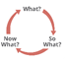Ask the young people to have a go by using the cycle to reflect on something relevant for them, this could be individually, in pairs or as small groups | To explore some existing cycles - this can be very simple, or more complex | Reflective cycles
Different ways to reflect | - Ask each young person to think for a few minutes about how they might reflect best  - Thinking on their own?  - Talking to others? Who?  - Writing something down?  - Through music or drama?  - Ask if anyone is happy to share an example of a time, they have used reflection or how they like to reflect | To get the young people to think about times they have used reflection in the past already, or what could work for them in the future
Reflection and our programme | - Say that using reflection will be key throughout our programme  - As a part of each the end of each stage and included in the Stage form will be a chance to reflect on that stage  - Use the roller coast reflection tool to encourage the young people to reflect on highs and lows during the programme  - This could be done individually, in pairs or as a group, if as a group then different peoples roller coasters could be draw on the same sheet to show different people’s experiences  - Draw out a ‘roller coaster’ (see resources column)  - Ask the young people to put on different highs and lows – what they felt and when  - Encourage the group to reflect on that what they learnt from that or did differently as a result (or their learning at this point on reflection) | 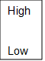To encourage young people, as individuals or a group, to reflect on their feelings and learning across the programme | Paper  Pens

