Future Talent: Young Entrepreneur Grants

Application Form

Before you apply ensure:
- You are on the Future Talent Programme or attend a Future Talent organisation
- You have a named youth worker who will support you
- You’ve read and understood the "Your Data and Privacy" section before you submit your details
Once that’s all sorted, please complete the below. The young person who completes the form, will be classed as the project leader, and will be responsible for keeping the project on track.

About You

Your First Name and Surname:
Date of Birth (DD/MM/YYYY):
Name of Youth Club/Organisation:
Your Email address:
Your Phone number:
What is your postcode?
Your preferred contact method:  Please tick all that work for you | Email Text WhatsApp Phone call
What is your gender? | Female  Male  Non-binary  Other  Prefer not to say
Is your gender identity the same as the gender you were assigned at birth?  (If you are not sure what this question means please ask an adult) | Yes  No  Prefer not to say
Do you consider yourself to have a disability?  (Disability is a long-term physical or mental impairment that has a substantial and long term negative impact on your ability to carry out day to day activities) | I don’t know  I do not have a disability  I have a disability  Prefer not to say

Choose one option that best describes your ethnic group or background:

Asian/Asian British |  | Mixed/Multiple ethnic groups
Bangladeshi |  | White and Asian
Chinese |  | White and Black African
Indian |  | White and Black Caribbean
Pakistani |  | Any other Mixed/Multiple ethnic background, please describe  _________________
Any other Asian background, please describe __________________ |  | White
Black/ African/Caribbean/Black British |  | British/English/Northern Irish//Scottish/ Welsh
African |  | Gypsy or Irish Traveller
Caribbean |  | Irish
Any other Black/African/Caribbean  background, please describe ______________ |  | Any other, please describe, _______________
 |  | Other ethnic group
 |  | Prefer not to say

About Your Project

What is your idea?
How will it help your youth club?
Which local employer do you plan to work with and how will you work together?

What is the timeline of your project?  (What will you achieve by when? Be as accurate as you can) | I’ll be planning my project from _____________ to  ____________  I will launch my campaign/event/project on  _______________________  I will reflect on and evaluate my project from ___________ to  _______________  My project will end by _____________________
How will you consider the safety of yourself and others on the project?

Who are the young people on your team?

How will you use your £500 budget?

Item | Price | Quantity | Total
Overall total |  |  | =

About your Youth Worker

Please get your named adult/youth worker to fill in this section. You will both need to sign the final page.

Your first and last name:
Name of your youth club/organisation:
Your email address:
Your work phone number:
If the applicant is selected to receive the London Youth Microgrant, do you agree to support them in the delivery of their social action project? | Yes  No
Do you have a current Disclosure and Barring Service (DBS) certificate? | Yes  No
Have you received safety and safeguarding training in the last three years? | Yes  No  If yes, please provide the date of the training  ____________________________
Please confirm the full address of your youth club

Being a named adult on this microgrants project will include:
- Supporting the young person on the project with their planning, delivery, evaluation and motivation
- Facilitating young people to take leadership roles as much as possible and prioritising the development of their leadership skills
- Completing an observational tool on the young person at the beginning and end of project
- Helping the young person to collect and submit all their monitoring and evaluation forms
- Ensuring appropriate safeguarding measures are always in place
- Ensuring your club has sufficient and appropriate liability insurance in place to cover its activities and any injuries to employees, volunteers, freelancers and participants, including incidents of abuse; and to ensure that all staff, volunteers and freelancers are DBS checked
- Obtaining parental permission for the young person taking part in the programme

Your Data and Privacy
Why we collect your information:
All personal information included on the forms is collected to administer your participation on the London Youth Microgrants programme.

How we use your information:
The information and data provided on the forms will be used to:

With your consent we may use photographs, video and audio recordings of young people to showcase and promote London Youth Microgrants and London Youth
Deliver the programme and monitor our activities. Your personal responses on this form will not be shared with anyone else and any reporting to others (including JP Morgan Chase foundation and others) will be a summary for the programme.
We may use some of your information as part of a case study, but your application will be anonymised if you would prefer, so you will not be personally identifiable

Contact you with opportunities relating to the microgrants and support you with any needs that you might have
We will not sell or share your information with any other parties.

Any sensitive data that is collected, including gender identity, disability and ethnicity is collected to meet our funder requirements and will be used purely for the purpose of understanding the demographic of people applying for the microgrant. You will not be personally identifiable by this information, and your completion of these sections is optional.

You have the right to request access to your data and for us to correct or delete your data by contacting us at the address below. You may withdraw your consent to us processing this data or request that we do not contact you at any time. However, that may mean that you will be unable to participate in some or all of the programme.

How we will store your information

The information provided on this form will be securely stored within Upshot, London Youth’s online monitoring and evaluation system. Your data will only be accessed by authorised personnel and authorised parties who are responsible for the maintenance and security of our digital systems.

If any parts of this form are unclear or you are unable to complete it yourself, then please let us know and a different form can be provided for your parent or guardian to complete with you.
For more information on our privacy policy, please visit londonyouth.org/privacy-policy/

I agree for my data to be stored and used in the ways specified above:

Young Person Signature: | Date:
Youth Worker Signature: | Date:
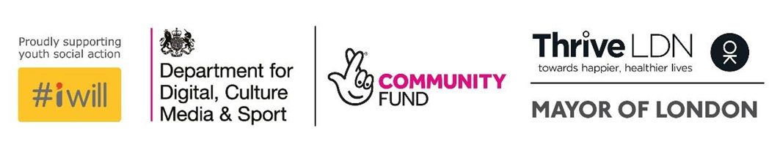
The Young Entrepreneur Microgrants is delivered in partnership with JPMC and Future Talent
You can email your completed applications to ella.porter@londonyouth.org
If you would prefer to apply via phone call, or you have any questions about the microgrants please contact Ella on ella.porter@londonyouth.org 07384 216257

