London Youth Microgrants
How do I get other young people involved?

The Behavioural insights team was the world’s first government programme to help apply behavioural sciences into the real world. ​
In their studies, they came up with the EAST model, which shows us 4 ways in which we can make things more interesting and engaging for wide audiences.
This model may help you think about how to get other young people involved in your microgrants project.

EAST MODEL
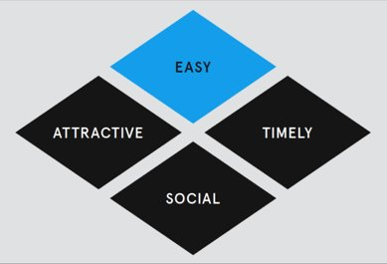
E – Easy
A – Attractive
S – Social
T - Timely

The Behavioural Insights team think that if you use all 4 of these methods together, people are more likely to engage with what you’re asking them to do.

Make it Easy​
Reduce the amount of effort it takes to get involved​
- Can you cover their travel costs?
- Can you go to them instead of them coming to you?
- Host your events at times when people are available and in the area.
Simplify messages
- Be very clear on what you are asking people to do
- Give them easy tasks they can accomplish

Make it Attractive​
Attract attention​
  - If you have flyers/posters/etc, ensure they are well presented. Ask people on their feedback on their layouts before you print your final version
  - Use social media and other methods to keep people updated with what is going on
Use rewards/incentives​
- Is there something you can offer people to get involved? – Prizes? Free food? A trip at the end?
Create a sense of fun and excitement
  - Describe your project in a way that makes people excited
  - Be enthusiastic and positive when talking to others about your project

Make it Social​
Use role models ​
- If you know someone who has a lot of friends or influence, perhaps you might want to convince them first and then get them to help you convince others
Help people to connect
- Buddy people up so they aren’t alone
- Help people learn from others
- Some people might be anxious about your project, be friendly to them to help them feel comfortable

Make it Timely​
Do the right thing at the right time ​
- Make sure your event or project is happening at the right time of day and year. For example, people might be less likely to come to things if it’s in exam time, or if the session is quite late on a school night.
Consider the immediate costs and benefits
- Track your progress and share successes with people as you go along. This will help your team stay motivated because they will be able to see the results of what they have been doing.

